CHILD PROTECTION AND SAFEGUARDING POLICY
INGATESTONE INFANT SCHOOL

APPROVED BY GOVERNORS [September 2025]
POLICY TO BE REVIEWED [September 2026]

DESIGNATED SAFEGUARDING LEAD:  (DSL) | Neil Taggart
DEPUTY DESIGNATED SAFEGUARDING LEAD:  (DDSL) | Marisa Read
DESIGNATED SAFEGUARDING GOVERNOR: | Louise Donno



To feel connected as a community through the delivery of an equitable, inclusive, and ambitious curriculum.

“I alone cannot change the world, but I can cast a stone across the waters to create many ripples.”
– Mother Teresa

Be Kind, Be Curious, Be Hopeful, Be Proud, Be You

Growing together, learning together, working together, and caring for each other.

Contents
1 | Introduction
2 | Statutory Framework
3 | Roles and responsibilities
4 | Types of abuse / specific safeguarding issues
5 | Procedures
6 | Children potentially at risk of greater harm
7 | Training
8 | Information sharing and confidentiality
9 | Child Protection records
10 | Interagency working
11 | Allegations about members of the workforce
12 | Behaviour, use of physical intervention and reasonable force
13 | Whistleblowing
Appendix A | Children and Families Service Map and Key Contacts
Appendix B | Essex Windscreen of Need and levels of intervention
Appendix C | Missing Children Protocol
- Introduction
Schools and their staff form part of the wider safeguarding system for children. Everyone who comes into contact with children and their families and carers has a role to play in safeguarding children. In order to fulfil this responsibility effectively, all professionals should make sure their approach is child-centred. This means that they should consider, at all times, what is in the best interests of the child.
(Keeping Children Safe in Education – DfE, 2025)

This Child Protection and Safeguarding Policy is for all staff, parents, governors, volunteers and the wider school community. It forms part of the safeguarding arrangements for our school and should be read in conjunction with the following:

- Keeping Children Safe in Education (DfE, 2025)
- the Behaviour policy
- the Staff Behaviour policy (sometimes called Staff Code of Conduct)
- the safeguarding response to children missing from education
- the role of the designated safeguarding lead (Annex C of KCSIE)

Safeguarding and promoting the welfare of children (everyone under the age of 18) is defined in Keeping Children Safe in Education as:

- Providing help and support to meet the needs of children as soon as problems emerge
- protecting children from maltreatment, whether that is within or outside the
home, including online
- preventing the impairment of children’s mental and physical health or development
- ensuring that children grow up in circumstances consistent with the provision of safe and effective care
- taking action to enable all children to have the best outcomes

Our school has a whole-school approach to safeguarding, which ensures that keeping children safe is at the heart of everything we do, and it underpins all systems, processes and policies. It is important that our values are understood and shared by all children, staff, parents/carers, governors and the wider school community. We believe that, only by working in partnership, can we truly keep children safe.

2. Statutory framework
There is government guidance set out in Working Together to Safeguard Children (DfE 2023) on how agencies must work in partnership to keep children safe. This guidance places a shared and equal duty on three Safeguarding Partners (the Local Authority, Police and Health) to work together to safeguard and promote the welfare of all children in their area under multi-agency safeguarding arrangements. These arrangements sit under the Essex Safeguarding Children Board (ESCB). In Essex, the statutory partners are Essex County Council, Essex Police and three NHS Integrated Care Boards covering the county.

Section 175 of the Education Act 2002 (Section 157 for Independent schools) places a statutory responsibility on the governing body to have policies and procedures in place that safeguard and promote the welfare of children who are pupils of the school.

In addition to national statutory guidance, in Essex, all professionals must work in accordance with the SET Procedures. Our school also works in accordance with the following legislation and guidance (this is not an exhaustive list):

- Keeping Children Safe in Education (DfE 2025)
- Working Together to Safeguard Children (DfE 2023)
- Working Together to Improve Attendance (DfE 2024)
- Education Act (2002)
- Essex Effective Support
- Counter-Terrorism and Security Act (HMG, 2015)
- Serious Crime Act 2015 (Home Office, 2015)
- Children and Social Work Act (2017)
- Children Missing Education - statutory guidance for local authorities (DfE, 2016)
- Sexual Offences Act (2003)
- Education (Pupil Registration) Regulations 2006
- Information Sharing (DfE 2024)
- Data Protection Act (2018)
- What to do if you're worried a child is being abused (HMG, 2015)
- Children Act (1989)
- Children Act (2004)
- Preventing and Tackling Bullying (DfE, 2017)
- Female Genital Mutilation Act 2003 (S. 74 - Serious Crime Act 2015)
- Teaching online safety in schools (DfE, 2023)
- Meeting digital and technology standards in schools and colleges (DfE 2025)
- Generative AI: product safety expectations (DfE 2025)
- Relationships Education, Relationships and Sex Education (RSE) and Health Education (DfE 2025)
- Behaviour in Schools (DfE 2024)
- School suspensions and permanent exclusions (DfE, 2024)
- Searching, screening and confiscation (DfE 2022)
- Understanding and supporting behaviour and appendices (ECC 2025)
- Meeting digital and technology standards in schools and colleges DfE 2025)
- Domestic Abuse Act (2021)
- Victims and Prisoners Act (2024)
- Education Access Team CME / Home Education policy and practice (ECC, 2023)

3. Roles and responsibilities
All adults working with or on behalf of children have a responsibility to protect them and to provide a safe environment in which they can learn and achieve their full potential. However, there are key people within schools, the Local Authority and other agencies who have specific responsibilities under child protection procedures. The names of those in our school with these specific responsibilities (the designated safeguarding lead and deputy designated safeguarding lead) are shown on the cover sheet of this document. However, we are clear that safeguarding is everyone’s responsibility and that everyone who comes into contact with children has a role to play.

The governing body
The governing body has overall responsibility for safeguarding in our school. It ensures that the policies, procedures and training in our school are effective and comply with the law at all times. It ensures that all required policies relating to safeguarding are in place, that the Child Protection Policy reflects statutory and local guidance and that it is reviewed at least annually.

The governor for safeguarding arrangements is named on the front cover of this document. This governor takes strategic responsibility at governing body level for safeguarding arrangements in our school and a ‘whole-school approach’ to this. The governing body ensures there is a named designated safeguarding lead and at least one deputy safeguarding lead in place (also named on the front cover).

The governing body ensures the school engages with statutory safeguarding partners and contributes to multi-agency working, in line with statutory and local guidance. It ensures that information is shared and stored appropriately and in accordance with statutory requirements.

The governing body ensures that all adults in our school (including governors / trustees) who work with children undergo safeguarding and child protection training at induction as appropriate and that it is regularly updated. All staff members receive regular safeguarding and child protection updates, at least annually, to provide them with the relevant skills and knowledge to keep our children safe.

The governing body ensures our pupils are taught about safeguarding (including online safety) through teaching and learning opportunities as part of a broad and balanced curriculum. We teach our children how to keep themselves safe and we work in accordance with statutory guidance to help children recognise and respond to risk and to prevent them from coming to harm. We comply with government regulations which make the subjects of Relationships Education (for primary age pupils) and Relationships and Sex Education (for secondary age pupils) and Health Education (for all pupils in state-funded schools) mandatory.

The governing body has specific duties around online safety and ensures we have appropriate filtering and monitoring systems in place to keep our children safe online.

The governing body is responsible for ensuring that adults in our school are suitable – this is done by:

- ensuring we have in place safer recruitment procedures that help to deter, reject or identify people who might abuse children
- ensuring we meet statutory responsibilities to check adults working with children and have recruitment and selection procedures in place (see the school’s ‘Safer Recruitment’ policy for further information)
- ensuring volunteers are appropriately supervised in school
- online safety (including strategic oversight of filtering and monitoring systems to support this)

The Headteacher
The Teachers’ Standards 2012 state that teachers (which includes headteachers) should safeguard children’s wellbeing and maintain public trust in the teaching profession as part of their professional duties. Our Headteacher works in accordance with all statutory requirements for safeguarding and is responsible for ensuring that safeguarding policies and procedures adopted by the governing body are followed by all staff.

The Designated Safeguarding Lead (and Deputy / Deputies)
The designated safeguarding lead in school has ultimate lead responsibility for safeguarding and child protection. Their role includes managing child protection referrals, working with other agencies, ensuring all staff are appropriately trained, leading on online safety (including filtering and monitoring standards) and raising awareness of all safeguarding and child protection policies and procedures. They ensure that everyone in school (including temporary staff, volunteers and contractors) is aware of these procedures and that they are followed at all times. They act as a source of advice and support for other staff (on child protection matters) and ensure that any referrals to Essex Children’s Social Care (Children and Families Hub) and / or the Police are made in a timely way and in accordance with current SET procedures. They work with the local authority and the ESCB as required and ensure that information is shared appropriately.

The deputy designated safeguarding lead/leads is/are trained to the same standard as the designated safeguarding lead. If for any reason the designated safeguarding lead is unavailable, the deputy designated safeguarding lead is able to act in their absence.

All school staff
Everyone in our school has a responsibility to provide a safe learning environment where our children can learn. All staff are aware of the types of abuse and safeguarding issues that can put children at risk of harm, so we are able to identify children who may need help or protection. We understand that behaviours linked to issues such as drug taking and/or alcohol misuse, missing education and consensual/non-consensual sharing of nudes and semi-nudes images can be signs that children are at risk. In addition, we recognise that any child may benefit from additional help and all staff members are aware of the local early help process and our role in it.

All staff members are aware of and follow school safeguarding processes (as set out in this policy) and are also aware of how to make a referral to Social Care, if there is a need to do so. Staff understand that, if they have any concerns about a child’s welfare, they must act on them immediately and speak with the designated safeguarding lead (or deputy) – we do not assume that others have acted.

Our staff understand that children may not always feel able or know how to tell someone that they are being abused. This may be because they are embarrassed, scared or do not recognise they are experiencing abuse, either at home or out in the community. We understand there are many factors which may impact on our children’s welfare and safety and we also understand safeguarding in the wider context (contextual safeguarding). We recognise that abuse, neglect and safeguarding issues rarely occur in isolation and that, in most cases, multiple issues will overlap.

Our staff will always reassure children who report abuse that they are taken seriously and that they will be supported and kept safe. We will never make a child feel ashamed for reporting abuse, nor make them feel they are causing a problem.

4. Types of abuse / specific safeguarding issues
Keeping Children Safe in Education describes abuse as ‘a form of maltreatment of a child’. It sets out that:

“Somebody may abuse or neglect a child by inflicting harm or by failing to act to prevent harm. Children may be abused in a family or in an institutional or community setting by those known to them or, more rarely, by others. Abuse can take place wholly online, or technology may be used to facilitate offline abuse. Children may be abused by an adult or adults or another child or children”

The guidance refers to four main categories of abuse:

- Physical: a form of abuse causing physical harm to a child – this includes where an adult fabricates or deliberately induces illness in a child
- Emotional: the persistent emotional maltreatment of a child such as to cause severe and adverse effects on the child’s emotional development
- Sexual: forcing or enticing a child to take part in sexual activities (through actual physical or online contact)
- Neglect: the persistent failure to meet a child’s basic physical and/or psychological needs, likely to result in the serious impairment of the child’s health or development

In addition, Annex B of Keeping Children Safe in Education contains important information about specific forms of abuse and safeguarding issues. Some of these, and our approach to them, are explained here:

Child criminal exploitation (CCE) and Child Sexual Exploitation (CSE)
Both CCE and CSE are forms of abuse that occur where an individual or group takes advantage of an imbalance in power to coerce, manipulate or deceive a child into taking part in sexual or criminal activity, in exchange for something the victim needs or wants, and/or for the financial advantage or increased status of the perpetrator or facilitator and/or through violence or the threat of violence. CSE and CCE can affect children, both male and female and can include children who have been moved (commonly referred to as trafficking) for the purpose of exploitation.

Some specific forms of CCE can include children being forced or manipulated into transporting drugs or money through county lines, working in cannabis factories, shoplifting or pickpocketing. They can also be forced or manipulated into committing vehicle crime or threatening/committing serious violence to others.

CSE is a form of child abuse, which can happen to boys and girls from any background or community. It may occur over time or be a one-off occurrence. In Essex, the definition of CSE from the Department of Education (DfE, 2017) has been adopted:

"Child Sexual Exploitation is a form of child sexual abuse. It occurs when an individual or group takes advantage of an imbalance of power to coerce, manipulate or deceive a child or young person under the age of 18 into sexual activity (a) in exchange for something the victim needs or wants, and/or (b) for the financial advantage or increased status of the perpetrator or facilitator. The victim may have been sexually exploited even if the sexual activity appears consensual. Child sexual exploitation does not always involve physical contact; it can also occur through the use of technology".

We recognise that a significant number of children who are victims of CSE go missing from home, care and education at some point. Our school is alert to the signs and indicators of a child becoming at risk of, or subject to, CSE and will take appropriate action to respond to any concerns. The designated safeguarding lead will lead on these issues and work with other agencies as appropriate.

Child on child abuse (including sexualised behaviours)
Child on child abuse can manifest itself in many ways. This may include bullying (including cyber bullying), physical abuse, harmful sexual behaviours, gender-related abuse, ‘up-skirting’, ‘sexting’ or initiation / hazing type violence and rituals. We do not tolerate harmful behaviour of any kind in school and will take swift action to intervene where this occurs, challenging inappropriate behaviours when they occur. We do not normalise abuse, and it is not tolerated in our setting. Our culture is very much one of kindness, compassion, hope, connection and belonging. This aligns with our own set of school values:

Respect, Enjoyment, Aspiration, Cooperation, Honesty

Any incidents of child on child abuse will be managed in the same way as any other child protection concern and we will follow the same procedures. We will seek advice and support from other agencies as necessary and ensure that appropriate agencies are involved when required.

Our school recognises that some children may abuse other children and that this may happen in school, or outside of it. We understand there are many factors which may lead a child to display abusive behaviours towards other children, and that these matters are sensitive and often complex. We recognise our school may be the only stable, secure and safe element in the lives of some children, particularly those who have experienced harm and trauma. We have a duty to safeguard all children and, whilst inappropriate behaviours will be challenged and addressed, it is in the context of providing appropriate support to all children in our school where harmful behaviour has occurred. We will always take a balanced and proportionate approach to risky or harmful behaviour.

We understand the barriers which may prevent a child from reporting abuse and work actively to remove these. We use lessons and assemblies to teach children about healthy, positive relationships, how to report concerns, and to help them understand, in an age-appropriate way, what abuse is. We aim to provide children with the language to report abuse and to tell a trusted adult if someone is behaving in a way that makes them feel uncomfortable. We will never make a child feel ashamed for reporting abuse, nor that they are creating a problem by doing so. We never assume, if abuse is not being reported, that it is not occurring in our school – we are vigilant to signs of abuse and promote a culture of safety and understanding.

Children who are absent from education
All children, regardless of their age, ability, aptitude and any special education needs they may have, are entitled to a full-time education. We recognise that good attendance begins with our school being somewhere our children want to be, and also that some children find it harder to attend school for a range of reasons. We will always try to understand underlying reasons for absence and will work collaboratively with other partners to support children to attend school and to ensure that they receive the right help at the right time.

A child missing education is a potential indicator of abuse or neglect, and we follow the procedures for unauthorised absence and for children missing education. It is also recognised that, when not in school, children may be vulnerable to or exposed to other risks. We believe that early intervention to address absence from school is vital, so we work with parents/carers and other partners to keep children in school and remove any barriers to them accessing their education.

Parents should always inform us of the reason for any absence. Where this does not happen, we will attempt contact with parents (parents are required to provide at least two emergency contact numbers to the school, to enable us to communicate with someone if we need to). Where contact is not made, a referral may be made to another appropriate agency (Education Access Team, Social Care or Police). Our school must inform the local authority of any pupil who has been absent without school permission for a continuous period of 10 days or more.

We work in accordance with the Essex Protocol for children who go missing during the school day (see Appendix C), to ensure that there is an appropriate response to children who go missing.

Risk in the community (RIC)
RIC is the Essex partnership approach to tackling criminal and sexual exploitation of children and young people.

We understand that safeguarding incidents and behaviours can be associated with factors in the community, outside a child’s home or our school. All staff are aware of ‘contextual safeguarding’ and we are therefore mindful of things in a child’s life which may be a threat to their safety and / or welfare. We always consider relevant information when assessing any risk to a child and will share it with other agencies when appropriate, to support better understanding of a child and their family. This is to ensure that our children and families receive the right help at the right time and to help keep our children safe.

Domestic abuse
Domestic abuse can involve a wide range of behaviours and can include intimate partner violence, abuse by family members, teenage relationship abuse and child to parent abuse. We understand that anyone can be a victim of domestic abuse, and that it can take place inside or outside of the home.

Our school recognises that exposure to domestic abuse (either by witnessing or experiencing it) can have a serious, long-term emotional and psychological impact on children. We work with other key partners, and we receive and share relevant information where there are concerns that domestic abuse may be an issue for a child or family, or be placing a child at risk of harm.
As part of our safeguarding arrangements and our work with safeguarding partners, our school has signed up to Operation Encompass. Operation Encompass is a national initiative which aims to provide support to children who have experienced domestic abuse. It means the Police inform us if they have attended an incident of domestic abuse which involves a child on our roll, so that appropriate support can be put in place. Any information in relation to this will be held on the child’s child protection file, as with any other safeguarding information.

Harmful sexual behaviour
We understand that children’s sexual behaviours exist on a continuum, ranging from age-appropriate / developmental to inappropriate / problematic / abusive. We also understand that harmful sexual behaviour and child-on-child abuse can occur between children of any age and gender, either in person or online. We recognise that children who display harmful sexual behaviour may have experienced their own abuse and trauma, and we will support them accordingly.

Our school has a ‘zero-tolerance’ approach to harmful sexual behaviour of any kind, and any inappropriate behaviour is challenged and addressed. We work in accordance with all statutory guidance in relation to such behaviours and with other agencies as appropriate.

We seek to teach our pupils about healthy and respectful relationships, boundaries and consent, equality, the law and how to keep themselves safe (on and offline).

Mental health
We recognise that good mental health for all our children and staff is very important, and we understand the part our school plays in this. We aim to develop the emotional wellbeing and resilience of all children and staff, as well as provide specific support for those with additional needs. We understand that there are risk factors which can increase someone’s vulnerability and also protective factors that can promote or strengthen resilience. The more risk factors present in someone’s life, the more protective factors or supportive interventions are needed to counter-balance these to promote resilience and keep children safe.

Our staff are aware that mental health problems can, in some cases, be an indicator that a child has suffered or is at risk of suffering abuse, neglect or exploitation. We understand that, where children have suffered abuse or other potentially traumatic adverse childhood experiences, this can have a lasting impact throughout childhood, adolescence and into adulthood. Where we have concerns this may impact on mental health, we will seek advice and work with other agencies as appropriate to support a child and ensure they receive the help they need.

It is vital that we work in partnership with parents/carers to support the wellbeing of our pupils. We expect parents/carers, if they have any concerns about the wellbeing of their child, to share this with us, so we can ensure that appropriate support and interventions can be identified and implemented.

Online safety
We recognise that our children are growing up in an increasingly complex world, living their lives on and offline. Whilst this presents many positive and exciting opportunities, we recognise it also presents challenges and risks, in the form of:

- content: being exposed to illegal, inappropriate or harmful material; for example, pornography, fake news, suicide, racist or radical and extremist views;
- contact: being subjected to harmful online interaction with other users; for example, peer to peer pressure, commercial advertising as well as adults posing as children or young adults with the intention to groom or exploit them for sexual, criminal, financial or other purposes;
- conduct: personal online behaviour that increases the likelihood of, or causes, harm; for example, making, sending and receiving explicit images, or online bullying
- commerce: risks such as online gambling, inappropriate advertising, phishing and / or financial scams

All staff in our school are aware of the risks to children online. We understand any child can be vulnerable online, and that their vulnerability can vary according to age, developmental stage and personal circumstances. We aim to equip all our pupils with the knowledge they need to use the internet and technology safely, and we want to work with parents to support them to keep their children safe online.

Children must be safeguarded from inappropriate and potentially harmful content online. We have systems in school to filter information and block internet access to harmful sites and inappropriate content. These systems are monitored and regularly reviewed to ensure they are effective, and all staff are trained in online safety and how to report concerns.

Prevention of radicalisation
As of July 2015, the Counter-Terrorism and Security Act (HMG, 2015) placed a duty on schools and other education providers. Under section 26 of the Act, schools are required, in the exercise of their functions, to have “due regard to the need to prevent people from being drawn into terrorism”. This duty is known as the Prevent duty.

The Prevent Duty requires schools to:

- teach a broad and balanced curriculum which promotes spiritual, moral, cultural, mental and physical development of pupils and prepares them for the opportunities, responsibilities and experiences of life and must promote community cohesion
- be safe spaces in which children / young people can understand and discuss sensitive topics, including terrorism and the extremist ideas that are part of terrorist ideology, and learn how to challenge these ideas
- be mindful of their existing duties to forbid political indoctrination and secure a balanced presentation of political issues

Channel is a national programme which focuses on providing support at an early stage to people identified as vulnerable to being drawn into terrorism. If a child on roll at our school is referred to the Channel Panel, a representative from the school may be asked to attend the Channel panel to help with an assessment and support plan.

Our school operates in accordance with local procedures for PREVENT and with other agencies, sharing information and concerns as appropriate. Where we have concerns about extremism or radicalisation, we will seek advice from appropriate agencies and, if necessary, refer to the Police, Social Care and/or the Channel Panel.

Serious violence
All staff are aware of the risk factors and indicators which may signal that children are at risk from or involved with serious violent crime. These may include increased absence from school, a change in friendships or relationships with older individuals or groups, a significant decline in performance, signs of self-harm or a significant change in wellbeing, or signs of assault or unexplained injuries. Unexplained gifts or new possessions could also indicate that a child has been approached by, or is involved with, individuals associated with criminal networks or gangs.

As with other safeguarding issues, we work with other relevant agencies to share information and address concerns, to help safeguard all children.

So-called ‘honour-based violence’ (including Female Genital Mutilation and forced marriage)
So-called ‘honour-based’ abuse (HBA) encompasses incidents or crimes which have been committed to protect or defend the honour of the family and/or the community, including female genital mutilation (FGM), forced marriage, and practices such as breast ironing. We understand that this form of abuse often involves a wider network of family or community pressure and can include multiple perpetrators.

Female Genital Mutilation (FGM) comprises all procedures involving partial or total removal of the external female genitalia or other injury to female genital organs. It is illegal in the UK and a form of child abuse.

As of October 2015, the Serious Crime Act 2015 (Home Office, 2015) introduced a duty on teachers (and other professionals) to notify the police of known cases of FGM where it appears to have been carried out on a girl under the age of 18. Our school operates in accordance with the statutory requirements relating to this issue, and in line with local safeguarding procedures.

A forced marriage is one entered into without the full consent of one or both parties. It is where violence, threats or other forms of coercion is used and is a crime. Our staff understand how to report concerns where this may be an issue.

5. Procedures
Our school works with key local partners to promote the welfare of children and protect them from harm. This includes providing a co-ordinated offer of early help when additional needs of children are identified and contributing to inter-agency plans which provide additional support (through a Child in Need or a Child Protection plan).

All staff members have a duty to identify and respond to suspected or actual abuse or disclosures of abuse. Any member of staff, volunteer or visitor to the school who receives a disclosure or allegation of abuse, or suspects that abuse may have occurred, must report it immediately to the designated safeguarding lead (or, in their absence, the deputy designated safeguarding lead).

All action is taken in accordance with the following guidance:

- Essex Safeguarding Children Board guidelines - the SET (Southend, Essex and Thurrock) Child Protection Procedures (ESCB, 2025)
- Essex Effective Support
- Keeping Children Safe in Education (DfE, 2025)
- Working Together to Safeguard Children (DfE, 2023)
- ‘Effective Support for Children and Families in Essex’ (ESCB)
- PREVENT Duty - Counter-Terrorism and Security Act (HMG, 2015)

Any staff member or visitor to the school must refer any concerns to the designated safeguarding lead or deputy designated safeguarding lead. Where there is risk of immediate harm, concerns will be referred by telephone to the Children and Families Hub and / or the Police. Less urgent concerns or requests for support will be sent to the Children and Families Hub via Essex Effective Support. We may also seek advice from Social Care or another appropriate agency about a concern if we are unsure how to respond to it. Wherever possible, we will share any safeguarding concerns, or an intention to refer a child to another agency, with parents or carers. However, we will not do so where it is felt that to do so could place a child at greater risk of harm or impede a criminal investigation. If it is necessary for an external agency to meet with a child in school, we will always seek to inform parents or carers, unless we are advised not to by that agency. On occasions, it may be necessary to consult with the Children and Families Hub and / or Essex Police for advice on when to share information with parents / carers.

All staff understand that, if they continue to have concerns about a child, feel a concern is not being addressed or that a situation does not appear to be improving for a child, they should raise this with the designated safeguarding lead.

Where an immediate response is required, and if for any reason the designated safeguarding lead (or deputy) is not immediately available, this will not delay any appropriate action being taken. Safeguarding contact details are displayed in the school to ensure that all staff members have access to urgent safeguarding support, should it be required. Any individual may refer to Social Care where there is suspected or actual risk of harm to a child.

When new staff, volunteers or regular visitors join our school they are informed of the safeguarding arrangements in place, the name of the designated safeguarding lead (and deputy/deputies) and how to share concerns with them. We also provide information on safeguarding to any visitor to our school, so they understand how to report a concern if they have one.

6. Children potentially at risk of greater harm
We recognise that some children may potentially be at risk of greater harm and require additional help and support. These may be children with a Child in Need or Child Protection Plan, those in Care or previously in Care or those requiring mental health support. We work with Social Care and other appropriate agencies to ensure there is a joined-up approach to planning for these children and that they receive the right help at the right time.

Our school understands that children with special educational needs (SEN) and / or disabilities can face additional safeguarding challenges. Barriers can exist when recognising abuse and neglect in this group of children. These can include:

- Assumptions that indicators of possible abuse such as behaviour, mood and injury relate to the child’s disability, without further exploration
- That they may be more prone to peer group isolation than others
- The potential to be disproportionally impacted by things like bullying, without outwardly showing signs
- Communication difficulties in overcoming these barriers

7. Training
In line with statutory requirements, the designated safeguarding lead (and deputy/deputies) undertake Level 3 child protection training at least every two years. The Headteacher, all staff members and governors receive appropriate child protection training which is regularly updated and in line with advice from the Essex Safeguarding Children Board (ESCB). In addition, all staff members and other adults working with children in our school receive safeguarding and child protection updates as required, but at least annually, to provide them with relevant skills and knowledge to safeguard children effectively. Records of any safeguarding / child protection training undertaken are kept for all staff and governors.

The school ensures that the designated safeguarding lead and deputies also undertake training in inter-agency working and other matters as appropriate.

8. Information sharing and confidentiality
Sharing information is a key part of safeguarding work and we understand that decisions about how much information to share, with whom and when, can have a profound impact on a child’s life. Our school is signed up to the Education and Learning Information Sharing Protocol which includes information sharing for safeguarding purposes. This protocol enables us to share and receive information with the Local Authority in a legal, safe, and secure way, to support our work in keeping children safe.

Where there are concerns about the safety of a child, the sharing of information in a timely and effective manner between organisations can reduce the risk of harm. Whilst the Data Protection Act 2018 places duties on organisations and individuals to process personal information fairly and lawfully, it is not a barrier to sharing information, where the failure to do so would result in a child or vulnerable adult being placed at risk of harm. Similarly, human rights concerns, such as respecting the right to a private and family life, would not prevent sharing information where there are real safeguarding concerns. Fears about sharing information cannot (and will not) stand in the way of the need to safeguard and promote the welfare of children at risk of abuse or neglect. Generic data flows related to child protection are recorded in our Records of Processing Activity and are regularly reviewed; and our online school privacy notices accurately reflect our use of data for child protection purposes.

A member of staff will never guarantee confidentiality to anyone (including parents/carers or pupils) about a safeguarding concern, nor promise to keep a secret. In accordance with statutory requirements, where there is a child protection concern, this must be reported to the designated safeguarding lead and may require further referral to and subsequent investigation by appropriate authorities.

In some cases, it may be necessary for the designated safeguarding lead (or deputy) to share information on individual child protection cases with other relevant staff members. This will be on a ‘need to know’ basis only and where it is in the child’s best interests to do so.

Information sharing can help to ensure that a child receives the right help at the right time and can prevent a concern from becoming more serious and difficult to address.

9. Child protection records
Accurate records are an essential aspect of effective child protection practice. Our school is clear about the need to record any concern held about a child or children within our school and when these records should be shared with other agencies.

Any member of staff receiving a disclosure of abuse or noticing signs or indicators of abuse will record it as soon as possible, noting what was said or seen (if appropriate, using a body map to record), giving the date, time and location. All records will be dated and signed and will include the action taken. This is then presented to the designated safeguarding lead (or deputy), who will decide on appropriate action and record this accordingly.

Any records relating to child protection are kept on an individual child protection file for that child (which is separate to the pupil file). All child protection records are stored securely and confidentially and will be retained for 25 years after the pupil’s date of birth, or until they transfer to another school / educational setting.

In line with statutory guidance, where a pupil transfers from our school to another school / educational setting (including colleges), their child protection records will be forwarded to the new setting. These will be marked ‘Confidential’ and for the attention of the receiving setting’s designated safeguarding lead, with a return address on the envelope so it can be returned to us if it goes astray. We will obtain evidence that the paperwork has been received by the new school and then destroy any copies held in our school. Where appropriate, the designated safeguarding lead may also contact the new setting in advance of the child’s move there, to enable planning so appropriate support is in place when the child arrives.

Where a pupil joins our school, we will request child protection records from the previous educational establishment (if none are received).

10. Interagency working
It is important that agencies work together to keep children safe, and there is a legal requirement to do so.

We work with other relevant agencies, such as Social Care, the Virtual School, Police and Health / mental health services to support children and keep them safe. This includes where a child in our school (or who was previously known to us) has a Child in Need, Child Protection or Care Plan. Where this is the case, it is the responsibility of the designated safeguarding lead to ensure our school is represented at, and that a report is submitted to, any statutory meeting called. Where possible and appropriate, any report will be shared in advance with the parent(s) / carer(s). The member of staff attending the meeting will be fully briefed on any issues or concerns the school has and be prepared to contribute to the discussions.

If a child is subject to a Care, Child Protection or a Child in Need plan, the designated safeguarding lead will have oversight of their school attendance, emotional well-being, academic progress, welfare and presentation, linking with the Essex Virtual School, which has strategic oversight of this group of children. Where our school is part of the core group, the designated safeguarding lead will ensure we are represented, provide appropriate information and contribute to the plan at these meetings. We will report on the child’s progress in school, and any concerns about them will be shared at the meeting, unless to do so would place them at risk of harm. In this case the designated safeguarding lead would speak with the child’s key-worker outside of the meeting, and as soon as there is a concern.

11.​ Allegations about members of the children’s workforce
We ensure all staff members (including agency staff) are made aware of the boundaries of appropriate behaviour and conduct. These matters form part of staff induction and are outlined in our Staff Behaviour policy / Code of Conduct. All staff are regularly reminded of this through updates and training, and are also informed about our Whistleblowing Policy.

Keeping Children Safe in Education (DfE 2025) and the SET procedures (ESCB 2025) set out the procedures in respect of allegations against an adult working with children (in a paid or voluntary capacity). These procedures should be followed where an adult has:

- behaved in a way that has harmed a child, or may have harmed a child and/or
- possibly committed a criminal offence against or related to a child, and/or
- behaved towards a child or children in a way that indicates he or she may pose a risk of harm to children, and/or
- behaved or may have behaved in a way that indicates they may not be suitable to work with children

Any concerns about an adult in our setting should be reported to the Headteacher or the designated safeguarding lead, who will then decide how to take this forward. In some cases, it might not be clear whether an incident constitutes an allegation. If this is the case, it will be necessary for us to explore the concerns to establish some facts – this initial fact-finding is not an investigation, it is to clarify information and to direct our response to the concern raised.

Where an allegation against a member of staff is received, and it is felt that any of the above criteria apply, the SET procedures (ESCB, 2025) require this to be reported to the Duty Local Authority Designated Officer (LADO) at the Essex Children’s Workforce Allegations Team at LADO@essex.gov.uk. We may not carry out any investigation before a Children’s Workforce Allegations Team referral has been made.

In the event of an allegation relating to the conduct and behaviour of an agency member of staff, the Headteacher (or Deputy) will liaise with the agency, while following due process, to facilitate a joint investigation or enable the agency to move this forward.

Any concern relating to the Headteacher should be reported directly to the Chair of Governors, who will refer the matter to the Children’s Workforce Allegations Team.

Staffing matters are confidential and the school operates within a statutory framework around Data Protection. We do not share information about any individual staff member with anyone other than appropriate statutory agencies.

12. Behaviour, use of physical intervention and reasonable force
Our Behaviour Policy sets out our approach to behaviour for all children and also for those with more difficult or harmful behaviour. We recognise there are some children who have needs that require additional support and a more personalised approach and we always consider all behaviour, and our response to it, in the context of safeguarding.

There are occasions when staff will have cause to have physical contact with children and young people for a variety of reasons, this may include:

- to comfort a child or young person in distress (appropriate to their age and individual specific needs identified through a risk assessment);
- to direct a child or young person;
- for curricular reasons (for example in PE, Music, Drama etc);
- in an emergency, to avert danger to the child, young person or others;

The guidance produced by the Department for Education Use of Reasonable Force (DfE, 2013) states that:

“Schools should not have a ‘no contact’ policy. There is a real risk that such a policy might place a member of staff in breach of their duty of care towards a child or young person or prevent them taking action needed to prevent a child or young person causing harm.”

The term ‘reasonable force’ covers a broad range of actions used by staff that involve a degree of physical contact to control or restrain children. There are circumstances when it is appropriate for staff to use reasonable force to safeguard children and young people, such as guiding a child to safety or breaking up a fight. ‘Reasonable’ means using no more force than is needed. Our school works in accordance with statutory and local guidance on the use of reasonable force (see section 2) and recognises that where intervention is required, it should always be considered in a safeguarding context

13. Whistleblowing
All members of staff and the wider school community should be able to raise concerns about poor or unsafe practice and feel confident any concern will be taken seriously by the school leadership team. We have ‘whistleblowing’ procedures in place and these are available in the Whistleblowing Policy. However, for any member of staff who feels unable to raise concerns internally, or where they feel their concerns have not been addressed, they may contact the NSPCC whistleblowing helpline on: 0800 028 0285 (line is available from 8:00 AM to 8:00 PM, Monday to Friday) or by email at: help@nspcc.org.uk.
Parents or others in the wider school community with concerns can contact the NSPCC general helpline on: 0808 800 5000 (24 hour helpline) or email: help@nspcc.org.uk.

Appendix A:
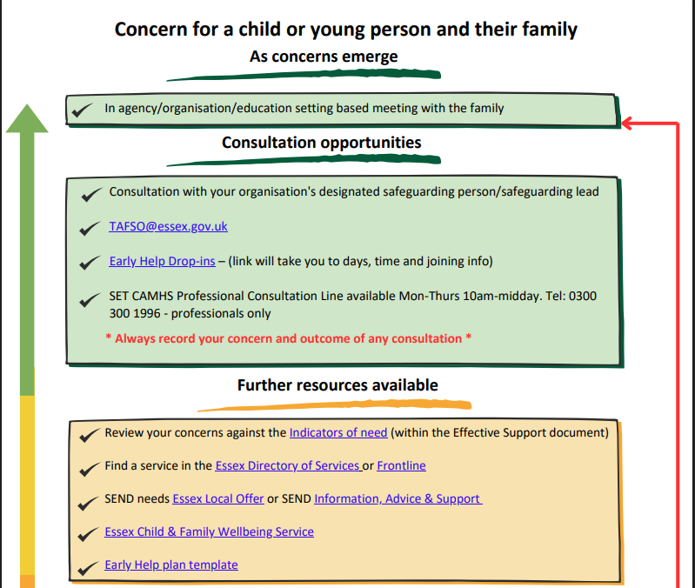

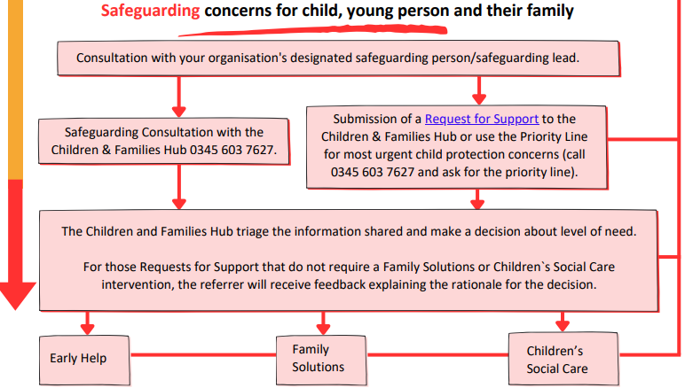

Appendix B: Essex Windscreen of Need and levels of intervention

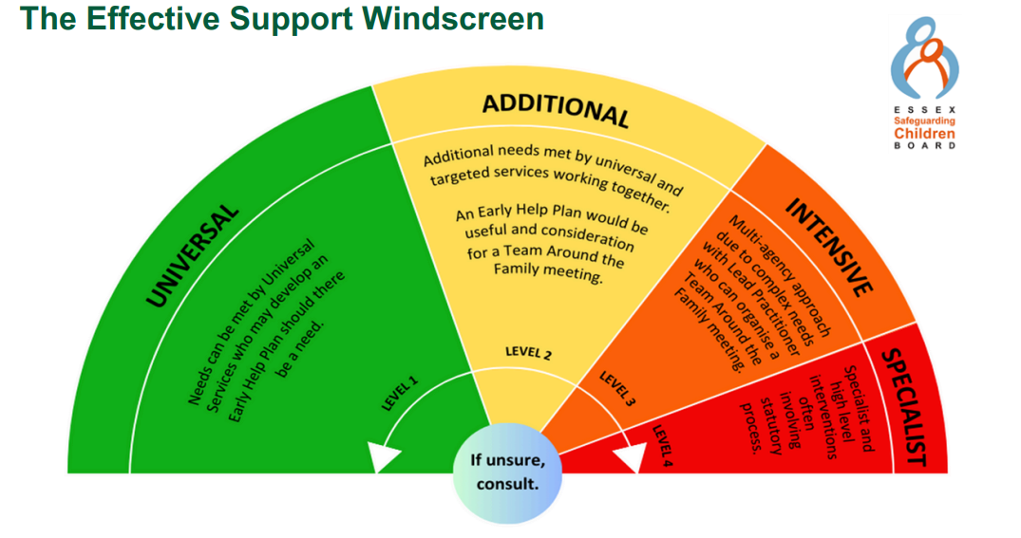

All partners working with children, young people and their families will offer support as soon as we are aware of any additional needs. We will always seek to work together to provide support to children, young people and their families at the lowest level possible in accordance with their needs.

Children with Additional needs are best supported by those who already work with them, such as Family Hubs or schools, organising additional support with local partners as needed. When an agency is supporting these children, an Early Help Plan and a Lead Professional are helpful to share information and co-ordinate work alongside the child and family.

For children whose needs are Intensive, a coordinated multi-disciplinary approach is usually best, involving either an Early Help Plan or a Shared Family Assessment (SFA), with a Lead Professional to work closely with the child and family to ensure they receive all the support they require. Examples of intensive services are children’s mental health services and Family Solutions.

Specialist services are where the needs of the child are so great that statutory and/or specialist intervention is required to keep them safe or to ensure their continued development. Examples of specialist services are Children’s Social Care or Youth Offending Service. By working together effectively with children that have additional needs and by providing coordinated multi-disciplinary/agency support and services for those with intensive needs, we seek to prevent more children and young people requiring statutory interventions and reactive specialist services.

Appendix C: Missing Child Protocol – arrangements for children who have missing episodes

Definition
The definition of missing used in Essex is ‘anyone whose whereabouts cannot be established will be considered as missing until located and his or her well-being confirmed’

(College of Policing Authorised Professional Practice Guidance).

Introduction
A child going missing could be a ‘one-off’ incident that, following investigation, does not need further work. However, multiple episodes of children who go missing can be an indicator of wider concerns (for example: exploitation, difficult home lives or poor mental health).
This guidance sets out the procedures to follow when children go missing from schools and other education settings, hereafter referred to as education settings. Missing children are among the most vulnerable in our community. Sometimes children go missing from education settings. When this occurs, it is important that action is taken quickly to address this, and in line with local procedures. This document should be read in conjunction with the education setting’s Child Protection Policy, and the Southend, Essex and Thurrock Child Protection Procedures (SET Procedures).
- Essex Schools Infolink – for the model Child Protection Policy and other resources
- Essex Safeguarding Children Board – for the SET Procedures and other resources
Education settings should consider missing episodes like any other child protection concern and take action as appropriate. This may include contacting parents/carers, the Children & Families Hub (CFH) consultation line or, in an emergency, the CFH priority line and / or the police. It may be appropriate to use the Early Help Procedures (including holding a Team Around the Family meeting) to identify underlying reasons for the missing episodes, address the issues and prevent escalation. Advice should be sought from appropriate partners, and concerns should be escalated if there is no improvement.
Education setting staff may be asked to attend strategy meetings for a missing child and should prioritise attendance at these meetings. Where children missing frequently are open to Children’s Social Care, a Missing Prevention Plan may be in place. Where this is the case, the education setting may be set actions as part of the Missing Prevention Plan and should receive a copy if consent has been provided.

When a child goes missing
When it is suspected that a child is missing from an education setting, this must be addressed immediately. Active steps to locate the child should be taken, for example, searching the premises and surrounding areas, attempting contact with the child by phone, text and social media, and contacting their parents/carers. If none of these actions locate the child, they must be reported missing to the Police by dialling 101, or 999 if there is a belief that the child is immediately suffering significant harm. It is important that the police are informed of any checks already completed as it may save time and prevent duplication of tasks set by the police to locate a child.
Education setting staff must inform the child’s parents/carers that the child has been reported missing. Where the child has a Social Worker, they should also be informed. After a child has been reported missing, any further information should be communicated to the police by telephoning 101 and quoting the incident number that the police would have provided following the initial report. Further information must be passed to the police as soon as possible, as officers will continue to search for the child until informed of their return.
When the child is found
If the child is found by education setting staff, or if the child returns to the premises of their own accord, the police must be notified immediately by dialling 101 or 999 if the matter is an emergency. It is important that this action is prioritised, as the child will remain classified as a missing person until seen by the police.
Essex Police
On receiving a report of a missing child, Essex Police will classify the child as missing and will respond based on the level of risk involved.
Essex Police will conduct a vulnerability interview for all children who have been missing and have returned. It may be that the child refuses to engage or speak with police. On these occasions the parents/carers can assist by reporting to officers their observations on the child’s return, e.g. did the child shower, have gifts, appear unwell or under the influence of any substance etc. The setting may also be able to contribute to this process and should provide the police with any relevant information or observations.

Missing Chats
Each child that returns from missing will be offered a ‘missing chat’ (an independent return from missing interview) by a person not involved in their care. This will be facilitated by the Local Authority with responsibility for the child. Missing chats are offered to all children from Essex who go missing.
Useful contacts:
Shane Thomson, ECC Missing Co-ordinator: shane.thomson@essex.gov.uk
Lucy Stovell, ECC Missing Chats: lucy.stovell@essex.gov.uk

